Python Coursework - Testing Documentation

Battleships – Oliver Favell S16115195

Objective | Screenshots | Explanation
Two players have two grids. | 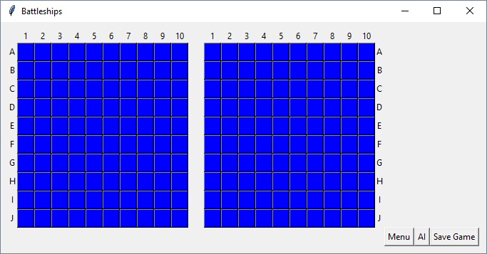 | The grid for player 1 is on the left, the grid for player 2 is on the right; the ships for each play are hidden unless attacked on the appropriate grid.
Each player can secretly position the ships on its primary grid. | 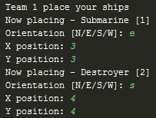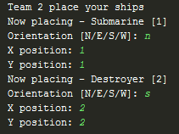  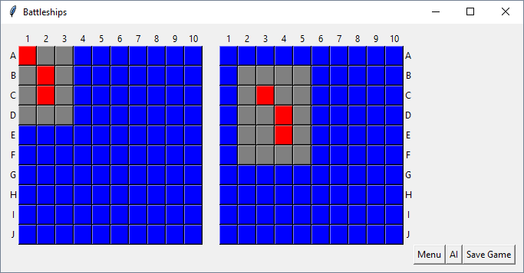 | Both teams place ships using a text interface, they can then be fired at using the grid. Note that the ships from player 2 are on the left grid, as that is the grid player 1 uses to attack, and vice versa.
Each player can position 5 types of ships either horizontally or vertically on the grid | 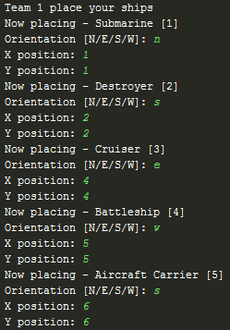  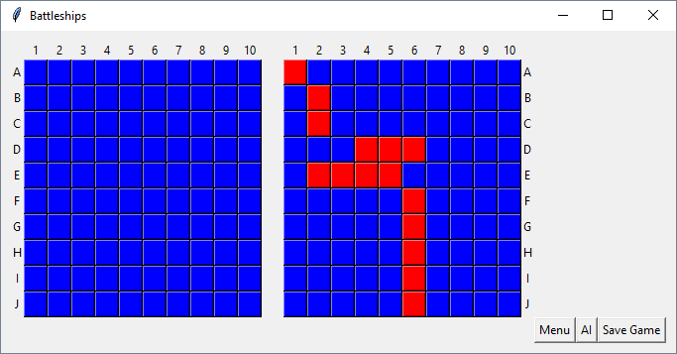 | Each player selects the orientation of the ship and its location. The placed ships are displayed in the grid, in their various orientations.
Players take turns to target opponent's grid. If hit the grid changes its colour to red, otherwise it turns to white for miss. | 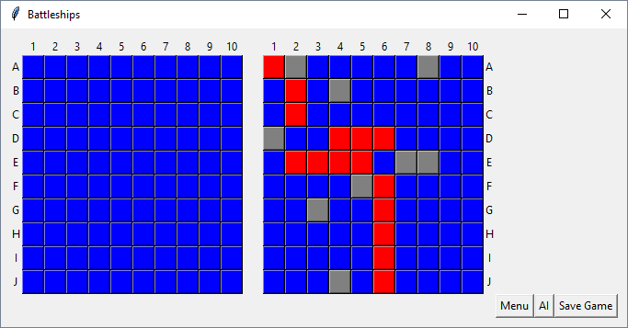  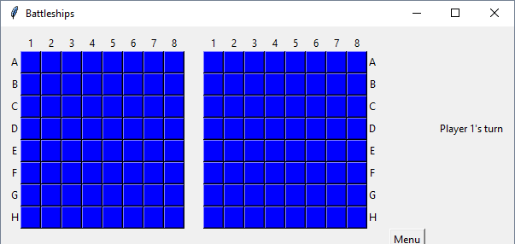  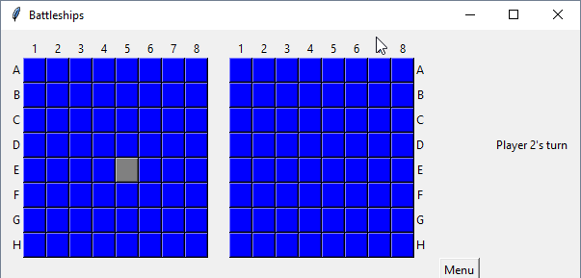  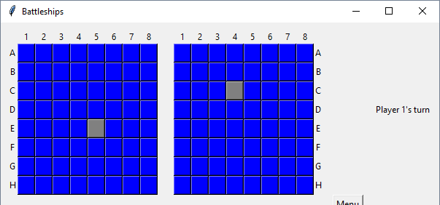 | Misses are in grey, hits are in red. Ship layout is the same as previously. Player’s turn is indicated by the label, and changes dependant on who’s turn it is.
When a player hits a hidden ship, the plyer is given an extra turn until it is a miss. | 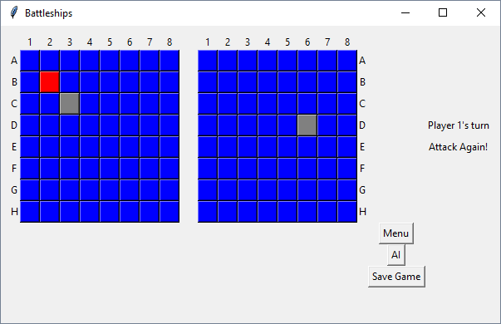 | After player 1 hits the ship they can attack again, as stated by the label on the right that appears after a successful hit.
Text based user interface is used to play the game. | See tests where text based input is used. | Text based input is used to positon to ships, and to print out what the computer is thinking and doing.
Computer player plays randomly. | See code file Gui.py, under the function compAttack. Code uses the random library to generate two random numbers that define that targeted position, which the computer then attacks. | The computer randomly selects a square on the grid and attacks that square
Development of Basic Graphical User Interface (GUI) using Python Tkinter. | See tests where Tkinter GUI is used. | Tkinter GUI is used to lay out the battle grid, and the start menu.
The game should announces the losing player and type of ship that was sunk. | 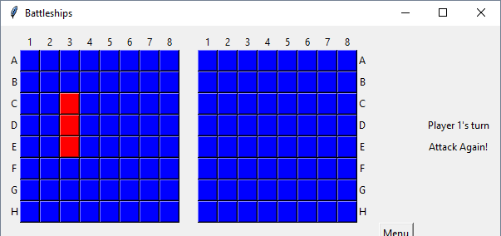 | When a ship is sunk the player it belongs to and the type of ship are displayed.
The game should announces the winning player when all opponent’s ships have sunk. | 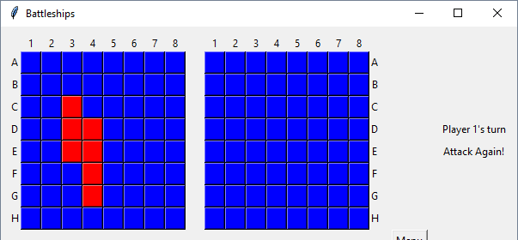
Computer player should allow some time before it target opponent’s grid. 2 seconds, emulating its thinking period even if the next move is random. | 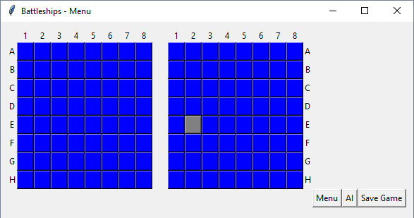  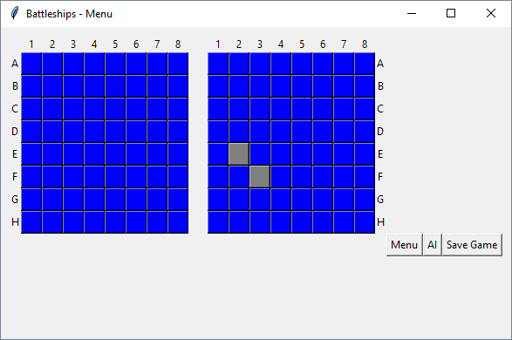 | The computer player pauses for 2 seconds to think before making a move and declaring that it is done.
Players can select the size of the grid at the beginning of the game. | 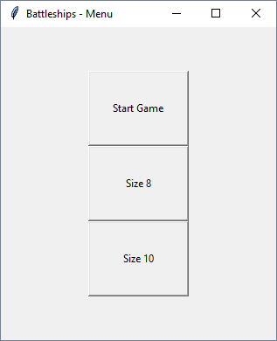  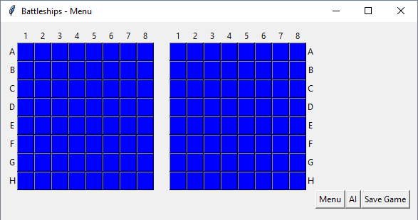  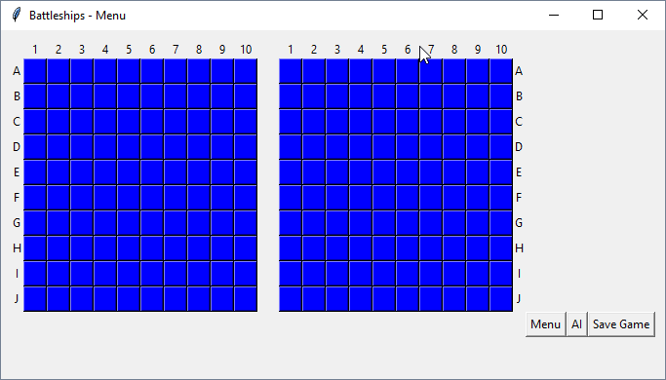 | There are size options for each size of board at the beginning of the game (8x8 and 10x10). Selecting one sets the size of the board and when Start Game is pressed that board is displayed.
The game must validate the positions of the ships. For example, the ships cannot overlap (i.e., only one ship can occupy any given square in the grid). | 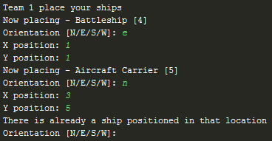 | Trying to place an aircraft carrier through a battleship, there is an error raised as there is already a ship positioned in the path of the aircraft carrier being placed, so the placement cycle resets.
Ships should only be placed within the game grid. | 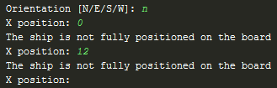 | Ships cannot be placed at location 0 or lower, as it is not on the board, or at a location higher than the board size.
The game can be saved and loaded into and from a text file. | 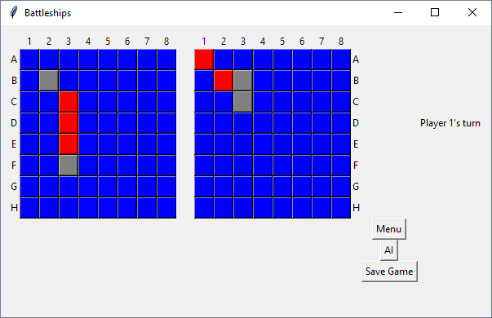  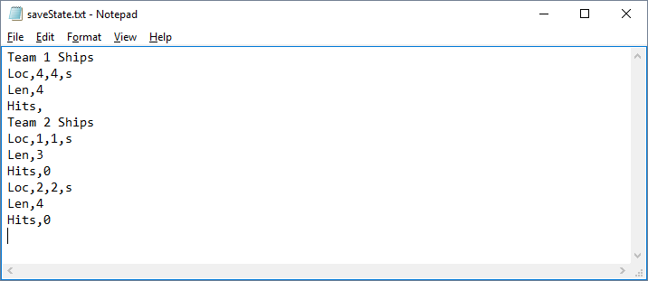 | Here is a sample game where each player has 2 ships; the hits and locations of the unsunk ships recorded in the file. The ship sunk on P1’s grid is not recorded as it is dead. Loading has not been implemented.

